Advisory Institute For Trade And Investment By TCC
University of the Thai Chamber of Commerce
Tel. +66(0) 26976357 ext.6357
Fax. +66(0) 2692-3161

- Big rise in consumer credit bids seen as recovery
- The Kingdom comes a step closer to 5G
- Farmers need more markets for sell crops
- Vangvieng-Luang Prabang expressway route approved
- Myanmar citizens raise investments in the country despite pandemic
- Binh Duong overfulfills yearly FDI attraction goal
- Car sales in Vietnam surge 15% in October

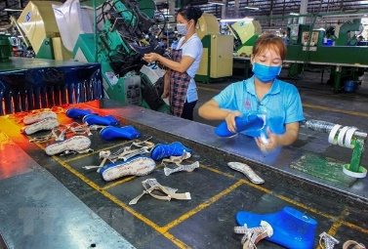
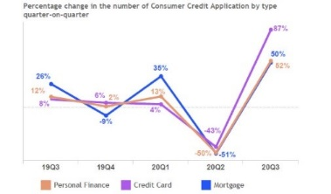
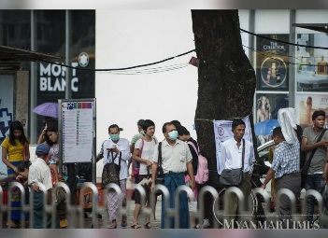
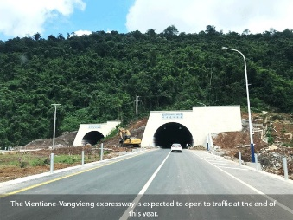
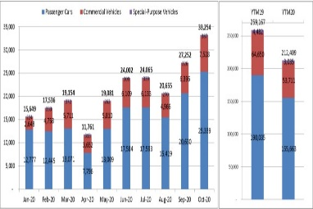
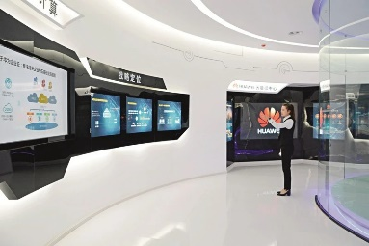

ADVISORY INSTITUTE FOR TRADE AND INVESTMENT BY TCC (AITI)

Highlight News November, 13/2020

05

Contract farming schemes on the rise: Ministry

Big rise in consumer credit bids
01

seen as recovery
Cambodia News I 12 November 2020
Consumer credit applications rose 53 percent in the third quarter of 2020, compared with figures for the second quarter of the year, according to a Credit Consumer Index report by the Credit Bureau of Cambodia (CBC). The CBC is the leading provider of credit information, analytical solutions and credit reporting services to banks, microfinance institutions, lending companies, credit operators and consumers in Cambodia. It began operations in 2012. Consumer credit applications represent consumers’ desire to acquire credit in the form of personal finance, credit cards or mortgages, said the CBC. This quarter’s rise in credit applications stands in contrast to a decline in credit applications in the second quarter of 2020 compared with first-quarter figures. The CBC noted that during the third quarter of 2020, personal finance applications rose by 52 percent, credit card applications were up by 83 percent and mortgage applications increased by 50 percent. A look at the same categories of second-quarter credit applications against first-quarter statistics shows personal finance applications dropped by 50 percent, credit card applications were down by 43 percent and mortgage applications fell by 51 percent. Oeur Sothearoath, chief executive officer of the CBC, said that the trends of the last few years suggest that this is indicative of a cyclical pattern of a rise in consumer credit applications in Q3 after a fall in Q2. He said that the same pattern extends to credit card applications as well. In addition, the economic slowdown contributed to a much stronger fall in consumer credit applications earlier in the year. “It is likely that the rise in Q3 2020 was much stronger than other years because of the market showing preliminary signs of stabilising and improvement after the sharp fall in Q2 2020,” Sothearoath added. PRASAC’s Executive Vice-President and Chief Marketing Officer Say Sony, welcomed the news as a good indication of economic recovery. He said that as of September 2020, PRASAC’s loan portfolio stood at $2.862 billion, an increase of 14.43 percent compared with 2019 figures. The loan portfolio mixture is 64.31 percent in business loans with the remaining 35.69 percent being personal loans. “People took on personal loans for a number of purposes. Among them being home improvement, real estate, automotive, green driven and emergency loans among others. However, as of September 2020 the demand for business loans was more robust than the demand for personal loans. That said, the portfolio quality of personal loans performed better than business loans,” Sony said. According to the CBC report, the ratio of late repayments 30 days past their due date, indicated as 30+DPD as of September 2020, was 2.42 percent on personal finance, credit cards and mortgages. This represents a drop from the 2.64 percent figure in June. The CBC added that the consumer loan balance by type as of September 2020, was $9.11 billion. The loan balance by category was split roughly 51.51 percent in mortgages, 47.90 percent in personal finance and 0.58 percent in credit cards. Sothearoath highlighted earlier that with the fast-paced changes in market conditions, the digitalisation of credit-risk management can help financial institutions to speed up and undertake more transparent and effective risk-profiling, risk-based pricing and portfolio management. He said the CBC is committed to delivering data, analytics and knowledge to enhance the efficiency of credit-risk operations, credit decision-making as well as contribute to financial-sector stability. “The CBC introduced two new products that blend data and digitalisation for credit-risk management to members of financial institutions, products that generate a measure of credit-worthiness known as a K-score,” he said. K-Score is a number that summarises all information in a borrower’s credit history to enable lenders to quickly assess the potential likelihood of default by borrowers. The second generation of K-Score will be commercially available this year, Sothearoath added.
02
Source: https://www.khmertimeskh.com/50782059/big-rise-in-consumer-credit-bids-seen-as-recovery/

The Kingdom comes a step closer to 5G
Cambodia News I 12 November 2020
Cellcard, part of the Royal Group of Companies, signed a major Framework Agreement with ZTE Corporation yesterday for the introduction of 5G and an increase of 4G coverage and capacity across Cambodia. The agreement comes at a critical time for Cellcard and Royal Group as they formalise plans for rolling out 5G as well as evolving its 4G long-term evolution (LTE) coverage and quality. The agreement covers a significant financial investment that will position Cambodia as one of the leading nations in the region for 5G adoption. Cellcard and the Royal Group’s vision are in direct support of the government’s agenda for Industry 4.0 to support the growth of the economy and gross domestic product (GDP) and to empower all Cambodians to benefit from the advantages of living in a digital society. Cellcard’s Chief Executive Officer Ian Watson said: “The Cellcard 5G network has already been a showcase. We have had live 5G demonstrations and reached the highest 5G speeds to date with 1.8 Gbps [gigabytes per second], Royal group have set the benchmark and today we express our readiness and commitment to the government to the next chapter for 5G that will revolutionise the way we do business, the way we communicate, the way we learn and the way we entertain.” Royal Group’s ICT Division of Cellcard, Wing Money, Ezecom and broadcasting operations CBS and Digital Sky are working in close collaboration for a shared digital strategy for Cambodia. The strategy will see a full transformation of the information and communication (ICT) sector as the roles of connectivity, data, content and security in people’s everyday lives change with the introduction of 5G and the large-scale adoption of technologies such as the internet of things, big data, artificial intelligence, virtual reality and augmented reality. Royal Group Chairman Neak Oknha Kith Meng said: Cellcard, together with the ICT Division operations, would ensure the introduction of 5G in Cambodia would be for a greater humanitarian impact to improve healthcare, education and security for all and help drive the future of a strong Cambodian economy. Cellcard and Royal Group believe the introduction of 5G and the digitalisation of Cambodia will fully support the government’s vision of industry 4.0. Royal Group will ensure a robust secure and highly advanced 5G service that will benefit all Cambodians. This will help fuel business growth, further develop and diversify the economy and improve healthcare, education and living standards for all.
03
Source : https://www.khmertimeskh.com/782058/the-kingdom-comes-a-step-closer-to-5g//
Farmers need more markets
for sell crops
Laos News I 13 November 2020
Farmers have urged the government to assist them in finding new markets - both local and overseas – to sell their produce. The requests were raised during the Lao Farmers Networking Knowledge Fair and General Assembly-2020 which was held over two days in Vientiane. The event was attended by over 150 participants, including 120 representatives of farmers from across the country, educational institutes, agriculture research centre, international organisations, and government officials. It was chaired by the Deputy Director General of the Department of Technical Extension and Agro-Processing, Mr Thongsavanh Phanthalavong, and the president of the Lao Farmers Network (LFN), Mr Khammoun Xaymany. This meeting was funded by the LURAS project. Numerous challenges faced by farmers were aired during the meeting. “We want the government to assist us and extend help to find new markets to sell our produce and to ensure a good price of our produce,” said a participant. Another issue that was raised was varied tax payments between districts and provinces and the need for a special subsidy for farmers’ electricity bills. “Farmers, especially in rural areas, need support with irrigation systems and spring water to ensure a good yield,” said a representative from LFN. The event encouraged participants to upgrade their plantation skills. New techniques of agriculture, which reduce the workforce but increase the harvest, as well as special policies for farmers which included 25 issues - such as agricultural techniques named “beautiful wife rice”, policy research on agricultural taxation policy, youth participation strategy, research on fall army worm outbreak in the northern provinces were shared with participants. Participants discussed the challenges faced by small farmers and the best five-year strategy plan from 2021-2025 of LFN. The event also had booths from national agriculture research centre for and agriculture organisations such as - SAMIS, WOCAT, LURAS, AFN-IFAD, CLEAN project, GAIA VITA. LFN’s members brought their products, including organic purple rice from Ban Jaeng village of Vientiane province, organic vegetables and crops from Thongmang organic vegetable cooperative, coffee soap and coffee beans from Pakxong district of Champassak province, cooking oil from Xieng khuang province, and others products for display.
04
Source: http://www.vientianetimes.org.la/
freeContent/FreeConten_Farmers222.php/
Vangvieng-Luang Prabang expressway route approved
Laos News I 13 November 2020
The government recently gave its approval to the route of the planned Vangvieng-Luang Prabang expressway – a highway that will shorten the drive between the two tourist hotspots to about 90 minutes. The go-ahead is another step towards the start of construction of the four-lane 136.9-km road. No start date has yet been set because there are still more preparatory works to be done, according to a source from the Laos-China joint venture company that is overseeing construction of the road. The developer is currently reporting the findings of a feasibility study to the Ministry of Public Works and Transport and awaiting approval. When it opens to traffic, the expressway will significantly cut travel time compared to a journey on the existing road, which takes many hours. The expressway is part of the planned 460-km Vientiane-Boten expressway, which will link Vientiane to Boten at the Lao-Chinese border. The Vientiane-Boten expressway comprises four sections -- Vientiane-Vangvieng, Vangvieng-Luang Prabang, Luang Prabang-Oudomxay and Oudomxay-Boten. Construction of the Vangvieng-Luang Prabang section will follow on from the almost-completed first stage - the 109-km Vientiane-Vangvieng expressway. This road is expected to open for public use at the end of the year, with travel time also estimated at about 90 minutes. Earlier this week, the developer and Oudomxay provincial authorities held a meeting to make decisions about the route that will run through the northern province, a senior official of the province’s Public Works and Transport Department, who attended the meeting, told Vientiane Times. The meeting agreed in principle in the 113.9-km corridor linking Luang Prabang city and Xay district in Oudomxay province, with travel time also estimated at 90 minutes. Upon approval of the corridor by local authorities, the developer will seek approval from the Ministry of Public Works and Transport and the government, the official said. Several factors have been taken into account when making decisions and approving the route. The factors focus on minimising social and environmental impacts and maximising economic returns, the official said. During the meeting in Oudomxay, the developer described the final section of the expressway, which will link Oudomxay’s Xay district and Luang Namtha province’s Boten at the Lao-Chinese border over a distance of 81.09 km. The journey time on this section is estimated at about one hour, according to a provincial television broadcast of the meeting. Once complete, it will take about five hours to drive between Vientiane and Boten on the 460-km Vientiane-Boten expressway. The route forms part of the Mekong sub-region highway network and is an important component of the Laos-China economic corridor. The Vientiane-Boten expressway will also connect to Asean Highway AH12 and will be part of the east Kunming-Bangkok highway, which is currently in the planning stages.
05
Source: http://www.vientianetimes.org.la
/freeContent/FreeConten_Vangvieng222.php.
Myanmar citizens raise investments in the country despite pandemic
Myanmar News I 12 November 2020
Despite COVID-19, Myanmar citizens’ investments across the regions and states for fiscal 2019-20 amounted to over K1.88 trillion, which is around K200 million higher than in the previous fiscal year, said U Thant Sin Lwin, Director General of the Directorate of Investment and Company and Administration (DICA).Approval was given to over 130 Myanmar businesses to invest in nine sectors during the period, data showed. Yangon Region received the highest volume of investments with over K 901 billion from 50 local investors. Mandalay Region received funds of K410 billion, while Shan and Ayeyarwady received K170 billion and K161 billion, respectively. Investors also channeled funds into Bago, Tanintharyi, Sagaing, Mon and Kayin. They also invested in the other states and regions, including the two poorest - Rakhine and Chin. The majority of the investments were in the industry, hotels and tourism and housing and development sectors. A handful of investors also channeled funds into the power supply, oil and gas and mining sectors, which is typically dominated by foreign investors. Despite the government’s plan to promote growth and value-add in agriculture, livestock and fisheries, few local firms invested in the sector. U Thant Si Lwin said each of the local investors is evaluated for operational viability by the Myanmar Investment Commission (MIC) before approval to invest is granted. The MIC then issues a Commercial Operation Certificate which enables investors to enjoy benefits such as tax relief and exemptions and other privileges. In fiscal 2019-20, over 23,000 job opportunities were generated as a result of Myanmar citizens’ investments, data showed. Some 22,700 locals and over 480 foreign workers were employed – Translated
Source : https://www.mmtimes.com/news/myanmar-citizens-raise-investments-country-despite-pandemic.html.
Binh Duong overfulfills yearly FDI attraction goal
Vietnam News I 12 November 2020
Binh Duong overfulfills yearly FDI attraction goal
Binh Duong (VNA) – The southern province of Binh Duong attracted about 1.7 billion USD of foreign direct investment (FDI) in the first 10 months of this year, exceeding the goal set for the whole year by 19 percent.Acccording Chairman of the provincial People’s Committee Nguyen Hoang Thao, the locality is still working hard to remove difficulties caused by the COVID-19 pandemic, towards completing its socio-economic target in 2020.Binh Duong’s industrial production index (IPI) is expected to increase 8.5 percent, and its total retail sales of goods and service to surge 15 percent in 2020.Meanwhile, the added value of the service sector is forecast to increase 7.3 percent, and the export and import turnovers to increase by 5 percent and 10.9 percent, respectively.The locality’s GDP growth is estimated at 6.78 percent and its per capita GRDP and the State budget revenue to reach 151.5 million VND (about 6,542 USD) and over 59.6 trillion VND in 2020.The local authorities have paid special attention to improving the investment environment and changing investment attraction methods in order to make the most of the current wave of capital and technology shifting in the region and the world, towards creating a premise for the locality’s economic breakthrough in 2021.The development of transport, logistics, and industrial park infrastructure has been also promoted, aiming to meeting the demand of investors./.
06
Source : : https://en.vietnamplus.vn/binh-duong-overfulfills-yearly-fdi-attraction-goal/190251.vnp.

Car sales in Vietnam surge 15%
in October
Vietnam News I 12 November 2020
The Hanoitimes - Car sales in Vietnam in the January–October period dropped 18% year-on-year to 212,409 units across all segments.The number of cars sold in Vietnam in October increased by 22% month-on-month and 15% year-on-year to 33,254 units, which came on the back of strong growth of 32% inter-monthly in the sales volume in September, according to data released monthly by the Vietnam Automobile Manufacturers Association (VAMA).The volume included 25,339 passenger cars, up 23% inter-monthly; 7,528 commercial cars, up 17%; and 387 special-purpose vehicles, up 71%. As many as 20,498 locally assembled cars were sold in October, up 15% against the previous month, and 12,756 imported cars were sold, up 35%.However, car sales in Vietnam in the January–October period dropped 18% year-on-year to 212,409 units across all segments. Upon breaking down, 155,663 were passenger cars, down 18% year-on-year; 53,711 were commercial vehicles, down 17%; and 3,035 were special-purpose vehicles, down 32%. Sales of domestically assembled cars reached 134,797 units during the period, down 12% compared to the same period of last year, while imported completely-built-units (CBUs) totaled 77,612 units (-26%).Truong Hai Auto Corporation (Thaco) led the market in the first ten months with 71,144 units sold, down 5% year-on-year and accounting for 34.8% of the total sales number, followed by TC Motor with 57,039 and Toyota with 49,950. Car imports surgeData from the General Department of Vietnam Customs showed the number of imported cars surged 43.4% month-on-month in September to 12,670 units, worth US$256 million. Notably, 94% of imported cars in Vietnam in September came from Thailand, Indonesia and China, with the corresponding volumes of 6,523, 4,574 and 796 units.Overall, 66,465 cars were imported into Vietnam between January and September for US$1.47 billion, down 37.2% year-on-year in volume and 38.2% in value.Customs statistics also showed that car accessories and parts worth US$2.66 billion were imported into Vietnam in the January–September period, down 13.5% year-on-year. Suppliers of those products were mainly from Japan, Thailand, China, and South Korea.Car making is considered a key industry in Vietnam, accounting for approximately 3% of national GDP. However, the industry has severely been impacted by the Covid-19 pandemic. Viet Dragon Securities Company predicted a decline of 15% made-in-Vietnam cars in sales volume this year.
07
Source : http://hanoitimes.vn/car-sales-in-vietnam-surge-15-in-october-314798.html.

